**Assignment 4: Mancala report**

Student: Mirza Sijamić

Student ID: msc25001

1. Explain the used utility function. Additionally, you have to add the code of the utility function to the report, explaining it with comments

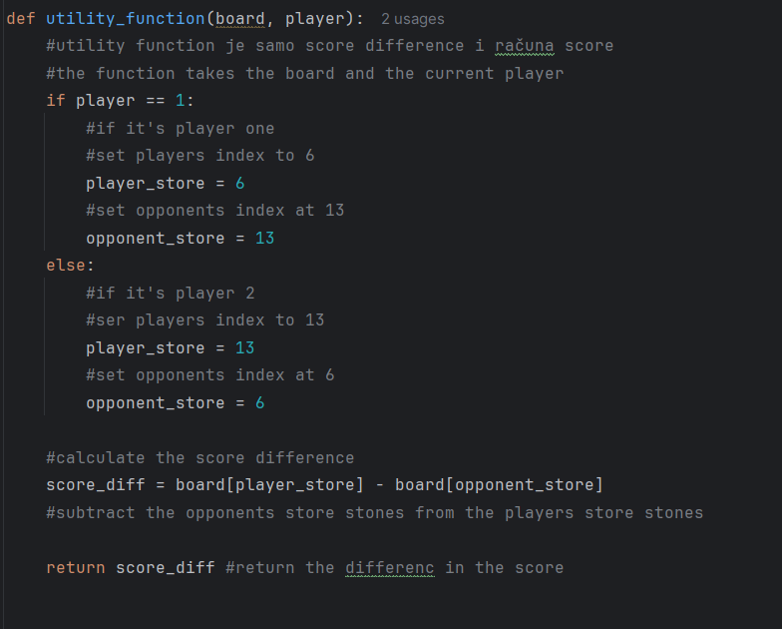

This function starts by determining the correct indices for the player's store and the opponent's store based on whether the player is 1 or 2. It then computes the score difference by subtracting the opponent's store value from the player's store value.

MinMax function  
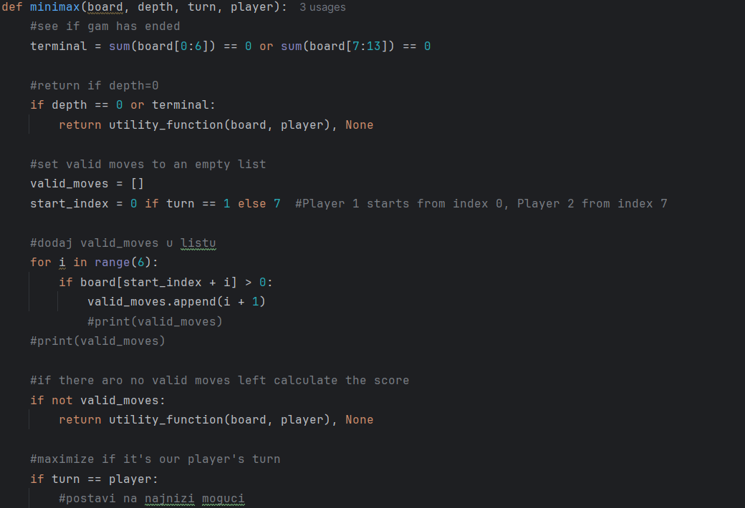

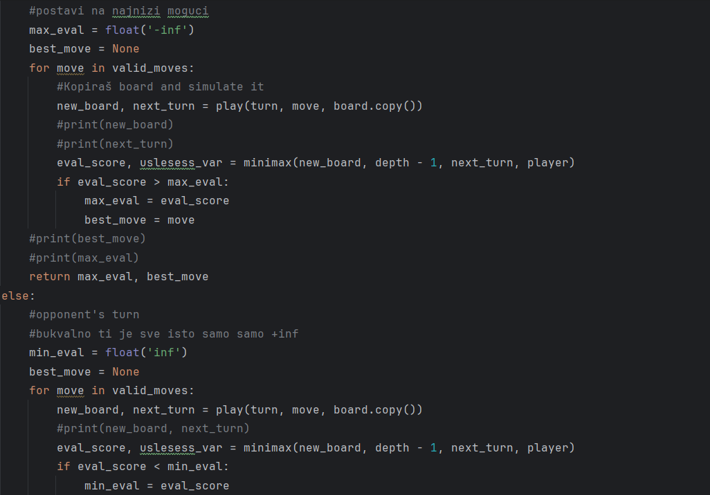

The minimax function is a recursive algorithm that cycles through different board states to account for potential future moves in the game. When the maximum search depth is reached or the pits on either side are empty, it first determines whether the game has reached a terminal state. If it has, it uses the utility function to return the evaluation of the board state. Otherwise, it simulates each move recursively after creating a list of the moves that are permitted for the current player based on which pits still contain stones. The function selects the move that maximizes the evaluation score during the current player's turn and the move that minimizes the evaluation score during the opponent's turn. This enables the algorithm to select the best move considering both players play perfectly.

Decide_move function  
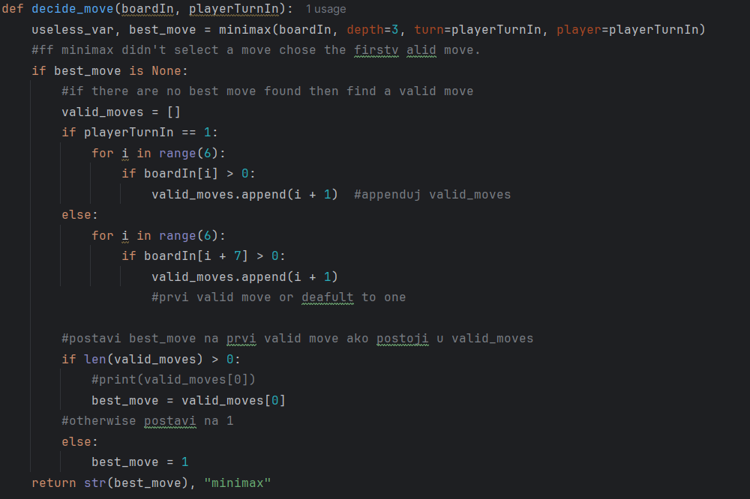

The move function, or play function in this program, is utilized to simulate the effect of a single move on the board. It starts by examining the move to see if the selected pit contains stones. It then removes all stones in the selected pit and distributes them one by one into next pits, skipping the opponent's store. After the stones are assigned, the function checks whether the move placed in the player's own bin, which would give an additional turn, or if it fell into an empty pit on the player's side, which would trigger capturing of stones from the other pit. Finally, the function returns the new board position and information on whose turn it is next.